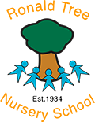

The Ronald Tree Curriculum
We play, learn and grow, inspiring all our children to be happy, lifelong learners!
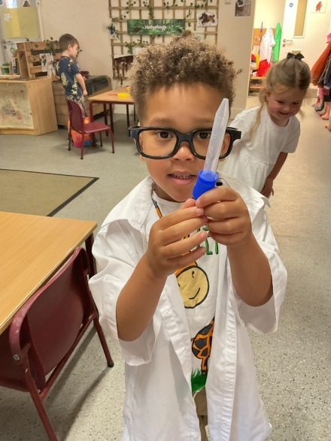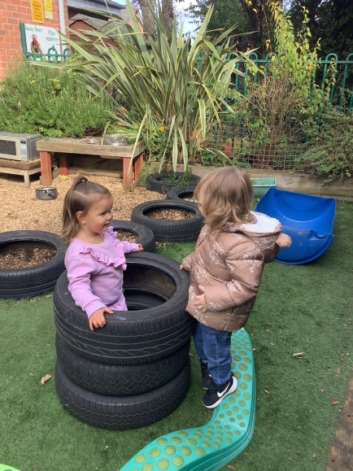
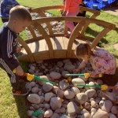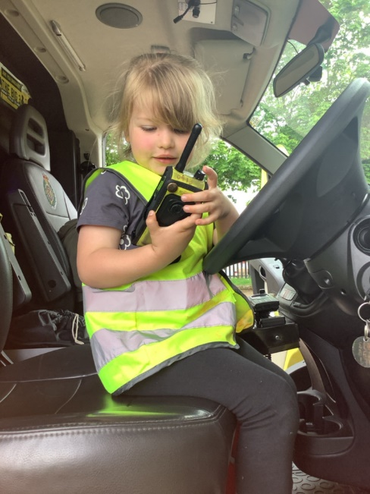


Our Vision

At Ronald Tree, our vision is to ensure all our children feel safe, understood and valued.
This means working from every unique starting point, providing engaging, playful learning for each individual child and their family.
We intend to send our children off to the next stage in their learning journey full of the skills, knowledge and confidence they need to achieve their very best.

Our Values
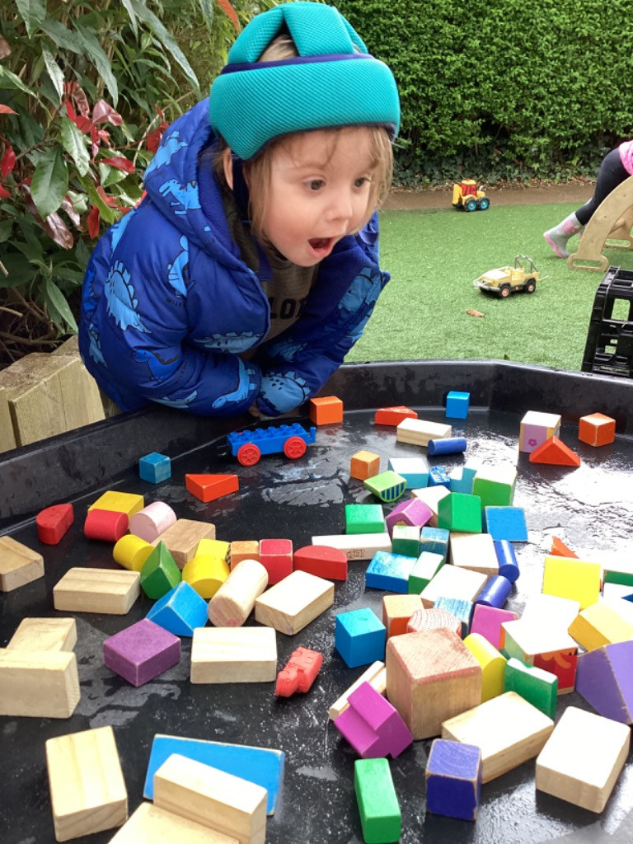
(The five Cs)
Confidence: having a strong sense of self
Consideration: respectful and understanding of others
Creativity: having our own ideas
Curiosity: investigating and exploring
Collaboration: working together

Curriculum Intent
At Ronald Tree, teaching and learning is centred around children's interests, fostering their autonomy to make decisions and solve problems in an adventurous, playful environment. We recognise there are many divergent pathways and constantly adapt to incorporate and celebrate them all. Our practitioners continuously work to enhance children's critical thinking and problem solving skills by providing them with new experiences and challenges. We aim to develop confident and active learners who question, investigate, and connect their ideas with those of others
Our setting provides enabling environments indoor and out that include opportunities for play in all its forms alongside adult led and child led exploration. Communication skills are integrated throughout.
Ronald Tree Readers consist of carefully chosen literature. Research shows that when children are immersed in rich language and imagination they go on to achieve the best outcomes across their education.
Our Skills Progression (pg 5-14) outlines the competencies every child at Ronald Tree should master at different ages, tailored to their individual developmental stages.
The Ronald Tree Knowledge (ap 1) encompasses a wide variety of experiences we believe all children should have before they reach the age of 5. This knowledge is taught at a developmentally appropriate level for each unique child, with key information identified to be understood by the time they leave for Reception

Implementation
Early Years Evidence Store | EEF
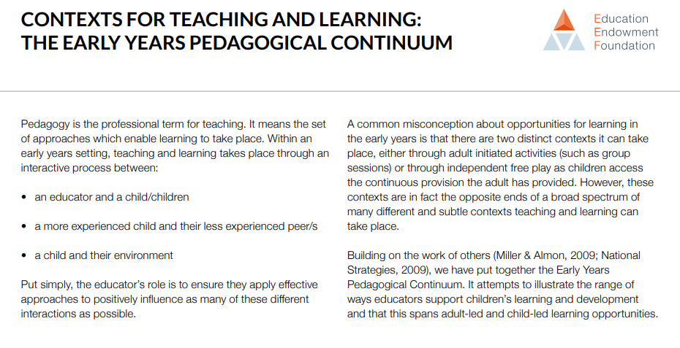
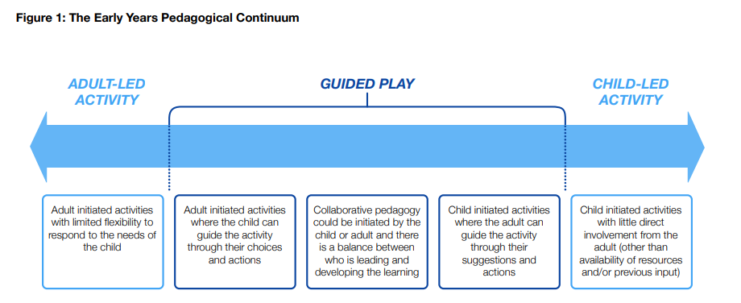
Aspects from a wide range of research and approaches have been incorporated into the Ronald Tree curriculum. These include:
https://www.gov.uk/government/publications/early-years-foundation-stage-framework--2
Development Matters - GOV.UK Early Years Toolkit | EEF
thecuriosityapproach.com/blog/what-is-the-curiosity-approach
https://annaephgrave.co.uk/
https://www.reggiochildren.it/en/reggio-emilia-approach/
Free Download – Play Matters Early Years Guide – Kinderly
Additionally, we draw inspiration from our observations of the children and the specific characteristics of our local community to create the tailored and meaningful educational experience.
Each child is assigned a dedicated key worker. They actively observe pupils to pinpoint teachable moments, determine next steps and move the learning forward in the moment. During planning sessions, shared themes and interests across the class are discussed. Provocations and starting points are planned to spark interest, foster skill development and promote high levels of involvement.
Key workers conduct ongoing assessments, which are summarised in termly focus child reports and data snapshots. Parents are actively encouraged to contribute to these reports and provide feedback on observations shared via our online learning journal; Tapestry. Staff use our skills progression and collaborate with colleagues during staff meetings to moderate assessments.
For pupils with learning differences, alternative tools such as the Portage Developmental Profile may be utilised. We employ a higher ratio of staff, provide an adapted environment and work alongside external professionals to ensure all our children reach their full potential.
To become confident at moving my body skilfully (Physical )
Teddies
- Gradually gain control of their whole body through continual practise of large movements such as waving kicking rolling crawling and walking
- Use small motor skills to do things independently, for example manage push buttons and pour drinks.
- Develop manipulation and control as they begin to use a range of small tools including scissors pens chalks and paintbrushes
- Fits themselves into spaces like tunnels dens and large boxes and move around in them
- Demonstrate increasing understanding for safety and manage risks with support

Little learners
- Demonstrate increasing control of their body including skipping hopping balancing and climbing apparatus
- Use tools and large objects as part of their play with increasing control [jugs brooms knives balls]
- Use one handed tools and equipment for example making snips in paper with scissors, squeezing pipettes or making lines with paint markers
- Start taking part in group activities which they make up for themselves or join as part of a group
- Show increasing independence in identifying risks and adjusting movements accordingly

Pre-schoolers
- Begin to match their physical skills to tasks and activities; eg deciding whether to walk crawl or run across the planks
- Can work with others to manage and move large items such as hollow blocks or planks
- Show a preference for a dominant hand and use a comfortable grip with good control when holding pens and pencils
- Follow a sequence and pattern of movements and play games which involve rules and collaboration
- Demonstrate an increased understanding of the need for safety and managing risks
To become a collaborative friend (PSE)
Link to Portage Developmental Profile
Teddies
- Plays happily alongside other children
- Joins in others play briefly
- Actively helps adults in everyday tasks
- Shows affection towards other children and familiar adults
- Willing to share toys and take turns
Little learners
- Seeks out others to share experiences and makes attachments to members of a group
- Engrossed in make believe in role play alongside others
- Form special friendship with another child
- Often show sensitivity to others
- Often actively seeks sharing and sense of fairness
- Show sense of humour
Pre-schoolers
- Become more outgoing with unfamiliar people in the safe context of their setting
- Works as part of a small group sharing fairly
- Develop appropriate ways of being assertive
- Understand gradually how others might be feeling
- Find solutions to conflicts and rivalries for example accepting that not everyone can be Spiderman
- Develop a positive self-image and show that they are comfortable with themselves

To become a confident communicator (C&L)

Link to Northamptonshire Health Care: Speech and Language Checklist– taken from talking point.org
Teddies
- Concentrate on activities for longer, like playing with a particular toy

Receptive language
- Listen to simple stories with pictures
- Understand and act on one step instructions – eg coat on, show me your nose, make it jump
- Listen to other peoples talk with interest but can be easily distracted

Expressive language
- Start to say how they are feeling using words and actions
- Start to put short sentences together with two to three words, such as more juice or bye nanny

Little Learners
- start play more with other children and share things
Receptive language
- Listen to, remember and talk about familiar stories
- Understand two-part instructions such as make teddy jump or where is mummy's coat
- Understand simple who what and where questions

Expressive language
- Put four or five words together to make short sentences such as I want more juice or he took my ball
- Ask lots of questions using words like what where and why
- Use action words as well as nouns such as run and fall
- Start to use simple plurals by adding S for example shoes or cars

Preschoolers
- Used talk to organise themselves in their play Eg - let's go on a bus you sit there I'll be the driver

Receptive language
- Listen to longer stories and answer questions about a story book they have just read
- Understand spoken instructions without stopping what they're doing to look at the speaker
- understand more complicated language such as first / last, might / maybe, yesterday/ tomorrow etc
- Think more about the meaning of words, such as describing the meaning of simple words or asking what a new word means

Expressive language
- Use longer sentences and link sentences together however they may still have some difficulties with grammar for example saying sheeps or goad
- Start a conversation with an adult or a friend and continue it for many turns
- Start to use tenses, but may still make mistakes eg runned and falled
- Describe events that have already happened

To become a creative Storyteller (Lit)
Teddies
- Have favourite books and seek them out to share with a friend or adult
- Pay attention and share simple stories showing an understanding of what is happening and respond to questions such as who, what, where?
- Enjoy drawing and making marks freely, adding some marks to their drawing which they give meaning to
- Notice some print such as the first letter of their name or a familiar logo
Little learners
- Follow a story which has a simple structure, retelling parts using story props and actions
- Join in with repeated refrains and simple repetitive songs and stories using new vocabulary in their play
- Understand print has meaning and begin to pay attention to the text and the illustrations as they retell a story
- Tell a simple story about something that they have experienced using prompts
- Talk about their mark making providing explanations of what their marks represent
- Begin to understand the concept of print and know that it carries meaning, begin to use it in their play (shopping list signs etc)
- Begin to recognise the initial letters in their name and attempt to copy it on paper
- Develop their phonological awareness by listening to and naming sounds they have heard
Pre-schoolers
- Remember the sequence of a simple story and retell in their own way using their imagination to extend the story
- Take part in pretend play using their imagination and adjust their speech when retelling a familiar story (adding voices for characters)
- Understand the function of text in books and retell a story for the adult to scribe (helicopter story)
- Retell a familiar story and talk about what happens, beginning to make marks or draw pictures to represent their ideas
- Respond to the print they see in the environment and identify some familiar letters
- Experiment more freely with writing for a purpose including writing notes, letters or shopping lists
- Begin to form some letters in their name with growing accuracy and confidence
- Use some of their print and letter knowledge in their early writing, understanding some letter sounds
- Develop their phonological awareness so that they can orally blend and segment

To become a curious explorer (UTW)
Link to British Values

Teddies
- Respond to natural phenomena in the setting and out and about (eg notice the rain, use scarves as kites in the wind, be interested in mini-beasts)
- Explore materials with different properties indoors and out, developing sensory experiences
- Repeat actions that have an effect (eg – rolling cars down a track, filling and emptying pots)
- Noticing differences between people– recognising and naming family members (and some staff)
- Making connections between the features of familiar people (eg noticing different hair, boys or girls)
- Role play different domestic scenarios

Little learners
- Make simple observations of the natural world and talk about what they see, hear and feel (eg Weather, minibeasts, plants)
- Begin to understand seeds and plants and what they ned to successfully grow
- Explore collections of materials with similar and/or different properties. Name some properties – eg soft, spiky
- Explore and develop vocabulary about different forces they feel (eg magnets, pushing and pulling, floating and sinking)
- Spends time looking at pictures of themselves, their family and other families and can talk about them (eg – that’s my brother. He is a baby. There’s Lilah’s baby…)
- Develop positive attitudes about the differences between people – talk about skin colour, languages, needs, celebrations
- Comment on buildings and features of their local area on walks
- Role play different jobs and experiences – eg firefighters, shop workers, parents

Pre-schoolers
- Begin to understand the need to care for the natural environment and for all living things
- Understand the key features of the life cycle of a plant and an animal and discuss using key introduced vocabulary.
- Talk about the differences between materials and changes they notice (eg wet sand changes colour, plastic can float, light and dark, cooking)
- Investigate cause and effect to make changes ( eg lifting ramps higher to adjust speed and distance, making boats to carry objects that sink )
- Begin to make sense of their own life history and talk about it (eg. I was a baby in mummy’s tummy. Nanny is daddy’s mummy)
- Know that there are different countries in the world and talk about differences they have experienced or seen in pictures
- Begin to make visual representations of their world using small world, paper, junk modelling
- Talk about different jobs and who they have seen in their community eg police officers, bus drivers, teachers

To become a considerate citizen (PSE)
Link to Characteristics of effective learning and British values
Teddies
- Find ways to calm themselves, through being calmed and comforted by their familiar adults
- Express preferences and start to try new things
- Manage transitions with the support of a familiar adult
- Growing independence - sometimes rejecting help and trying for themselves
- Learn to use the toilet with help
- Be able to drink from a lidded cup and sits at the snack table with support
- Actively helps with dressing and undressing
- Begin to show ‘effort full control’. Eg resisting the impulse to push
- Show goal oriented behaviour eg – reaching for their cup or finding a favourite book
Little learners
- Talk about their feelings, using words like happy sad angry or worried & be increasingly able to manage their emotions
- Bring their own interests and fascination's into the setting into their play
- Adapt to a variety of transitions throughout the school day – eg coming in from the garden
- ‘Having a go’ at self help activities with adult support eg – putting their coat on, tidying the toys
- Toilet trained, reliably clean and dry during the day
- Independently access snack
- Increasingly follows rules, understanding why they are important
- Keep on trying when things are difficult
Pre-schoolers
- Identify and moderate their own feelings socially and emotionally
- Become engaged with new experiences that adults bring to their attention
- Understand the behaviour expectations of different parts of the school day eg: sitting for lunch, lining up for playground
- Be increasingly independent in meeting their own care needs EG putting their coat on, using the toilets, washing and drying their hands thoroughly
- Make healthy choices about food drink activity and toothbrushing
- Remember rules without needing an adult to remind them
- Show resilience and perseverance in the face of challenge
To become a creative artist (EAD)

Teddies
- To begin to make marks intentionally including exploring paint using their fingers
- Explore and investigates a range of different media using all their senses including clay, cornflour and malleable materials
- Use their imagination as they consider what they can do with different materials and give meaning to the marks they make
- To join in with songs and rhymes
- To participate in small groups responding to music with dance and movement

Little learners
- Create closed shapes with continuous lines and begin to use these shapes to represent objects
- Join different materials and explore different textures including exploring loose parts
- Develop their own ideas and decide which materials to use to express them
- Sing some recognisable songs and join in with actions and rhymes
- Explore a range of sound makers and instruments and play in different ways

Pre-schoolers
- Draw with increasing complexity in detail such as representing a face with a circle and including details.
- Begin to name, talk about and explore colours and colour mixing creatively
- Design, create and make using loose parts and collage and talk about their artwork discussing colours, shapes, texture and materials used and what it represents to them
- Create collaboratively sharing ideas resources and skills, solving problems as they arise
- Remembers and sings an entire song by heart
- Create own songs or improvise a song around one they already know
- Play an instrument with increasing control, expressing feelings and ideas

Appendices:
To become a confident problem solver (Maths)


