British Values Statement

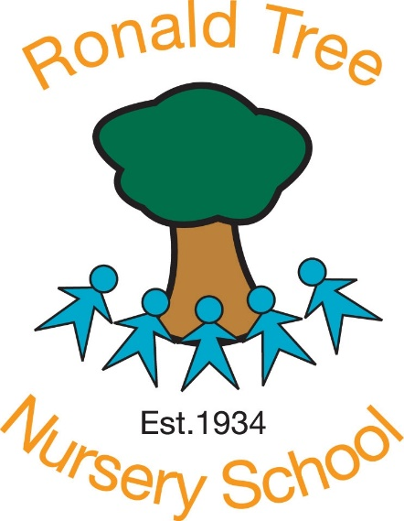

Last reviewed on: | Feb 25 by Deb Thwaites
Next review due : | Feb 2026

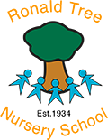
British Values at Ronald Tree

Staff at Ronald Tree Nursery School work with many children and families who originate from all over the world. There are many different languages spoken in our setting.
We value this diversity and aim to celebrate the many cultures this brings to our nursery.
British values are woven throughout our curriculum and mirrored in the 5 core values at Ronald Tree: Confidence, Consideration, Collaboration, Curiosity and Creativity.
These values form a fundamental part of the Early Years Foundation stage, identified most significantly in the Characteristics of Effective Teaching and Learning and Personal, Social and Emotional strand of the curriculum. We have included some examples from the EYFS to highlight this.

Democracy: making decisions together

EYFS (PSED): ‘Through supported interaction with other children they learn how to make good friendships, co-operate and resolve conflicts peaceably.’

Staff at Ronald Tree support the decisions that children make and offer open ended provision to encourage sharing, turn-taking and collaboration. Children learn that their way is not the only way and may be given opportunities to vote on tasks and activities.

Rule of Law: understanding rules matter

EYFS (PSED): ‘Increasingly follow rules, understanding why they are important’

Our curriculum at Ronald Tree identifies the need for consistent routines and expectations for the children in our care. For example tidying up together and treating others kindly. Children work with the adults to come up with rules for the setting and understand why they are needed.

Individual Liberty: freedom for all

EYFS (Cof ET&L): ‘Bring their own interests and fascinations into early years settings’

Children should develop a positive sense of themselves. At Ronald Tree we are led by the child and plan in the moment with them to develop their interests. We follow a child led approach and plan in the moment as we work with our families.

Mutual respect and tolerance: treat others as you want to be treated

EYFS (Cof ET&L): ‘Use pretend play to understand another perspective’

Ronald Tree has an ethos of inclusivity and tolerance, where views, faith, cultures and races are valued. We aim to engage with the wider community.
Staff promote diversity and challenge stereotypes through role play, discussion and stories.

