At Ronald Tree Nursery:
We play, learn and grow!






Welcome to Ronald Tree Nursery School


We play, learn and grow, inspiring our children to be happy, lifelong learners.

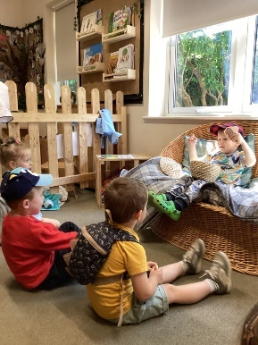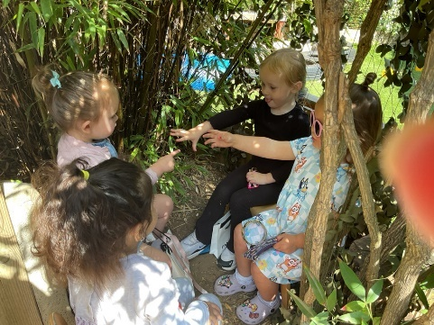
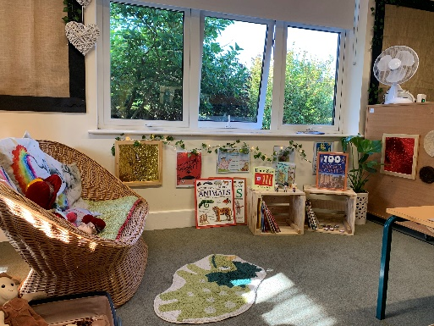

Please read this leaflet carefully.
If you have any questions please telephone the office on
01536-514240
Our Vision 

At Ronald Tree, our vision is to ensure all our children feel safe, understood and valued.
This means working from every unique starting point, providing engaging, playful learning for each individual child and their family.
We intend to send our children off to the next stage in their learning journey full of the skills, knowledge and confidence they need to achieve their very best.

Our Values

(The five Cs)
Confidence: having a strong sense of self
Consideration: respectful and understanding of others
Creativity: having our own ideas
Curiosity: investigating and exploring
Collaboration: working together

How to contact us

Phone: 01536 514240
Email: finance@ronaldtreenursery.co.uk
Website: www.ronaldtreenursery.co.uk

Ronald Tree Nursery School
Laburnum Crescent
KETTERING
NN16 9PH

Safeguarding

Everyone at Ronald Tree is committed to keeping every child safe. If we have any concerns, we will share them with parents/ carers as soon as possible. We are obliged to pass on information and involve relevant services if we believe a child is at risk of harm.
If you have any concerns about a child, please ask to speak to one of our safeguarding team:




Deb Thwaites
Headteacher
Safeguarding Lead
Mel Perkins
Family Support Worker
Deputy Safeguarding Lead

Remember to follow us on Facebook for news & information. Our weekly updates and termly newsletters are posted on Tapestry. Our Safeguarding policy, many other policies and privacy notices are all available on our website.
Working with Families
Ronald Tree is committed to working together with our families to provide the best possible start to the lives of our children.
Throughout the year, Mel, our Family Support worker runs parent sessions in the community centre next door to the school.
Each week there will be a parent drop in on Thursdays. They run at either 8.30-10.30 or 12.30-2.30 …or some weeks even both!
In these sessions, you can choose to bring your child for a stay and play or drop them for their usual nursery session and come over for a breather,
In addition, at different times in the school year, Mel and Liz run specific parent sessions using a toolkit named ‘PEEP’ to address any areas families would like more information on, such as managing tricky behaviour, early story sharing or messy art play!
We invite local services such as Home Start, Family Hubs and Adult learning to drop in and share their expertise and advice.

Each year there are also several events in which we encourage parents to come into school and play alongside their children. We aim to have at least one of these play sessions each half term.

Families are also invited to join us on trips out and about in the local community eg ‘The Green Patch’ or to come in and join our music sessions or Christmas sing-a-long at St Mary’s Church.

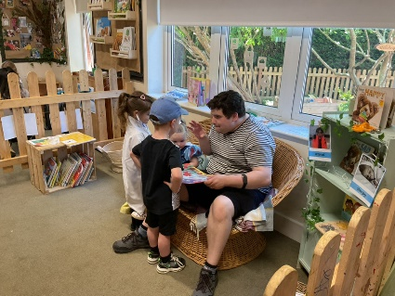

Our curriculum goals

To become a confident communicator
To become a considerate citizen
To become a confident problem solver
To become a creative storyteller
To become a curious explorer
To become a collaborative friend
To become confident at moving my body skilfully
To become a creative artist

Our Full curriculum document can be found on our website

Our Ronald Tree Family – The Staff Team

Addie Holmes
Cleaner in Charge
Mandy Coles
School Business Manager
Jackie Wilson
Teacher
Debra Thwaites
Headteacher

Key Workers and Assistants

Agata Kwiecien
Teddy Bear Keyworker
Carmela Clark
Nursery worker
Sarah Towell
Teddy Bear Keyworker
Adele Randall
Nursery worker
Ewelina Gurkalo
Nursery Worker /Cleaner




Carol Walding
Early Years Assistant
Liz Jones
Green AM Keyworker

Julie Hands
Yellow Keyworker

Jemma Hawkes
Red Keyworker
Yasmin Heath
Green Keyworker All Day



Carolyn Carter
Tiger Keyworker
Emma Weekley
Tiger Keyworker
Janna Richards
Blue Keyworker

Lisa Clark
Orange Keyworker
Vicky Morris
Purple Keyworker


Mel Perkins Family
Support Worker

Christina Redden
Finance and Admin

The Knowledge!
This is the knowledge we believe children should have by the time they reach five. We offer experiences that provide children with the opportunity to discover more, learn more, remember more, and understand more.
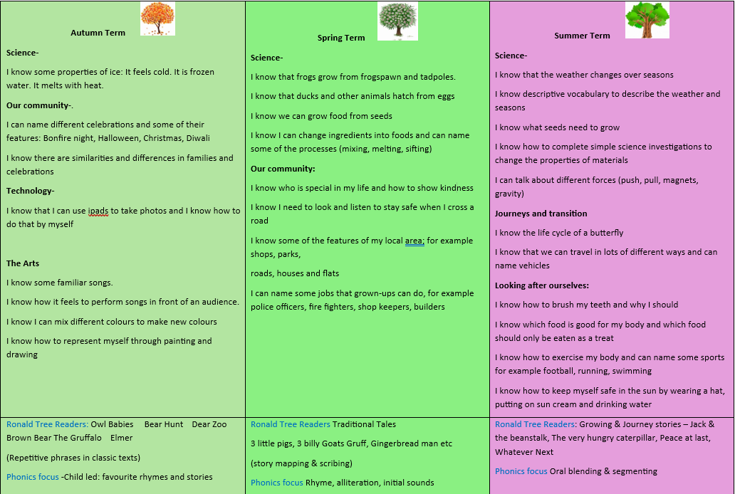

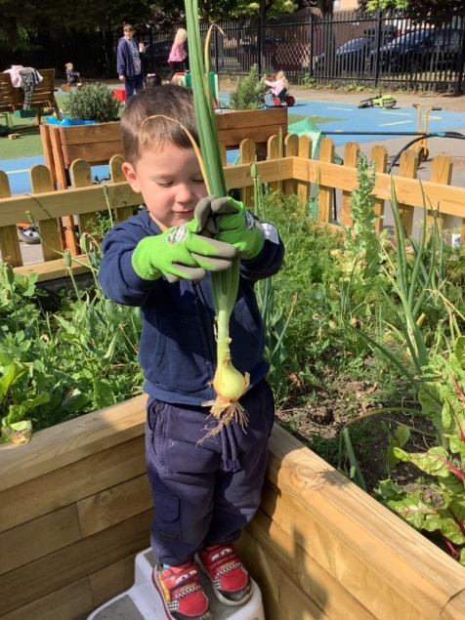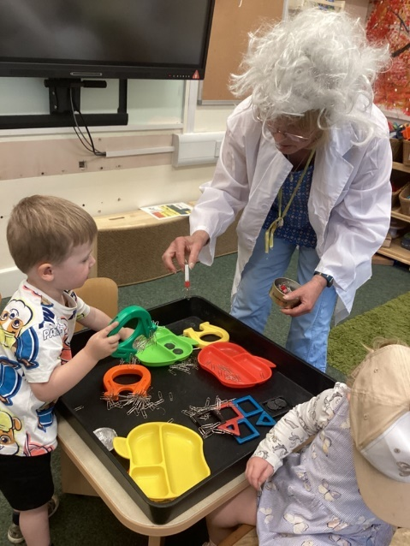

What do I need to bring with my child?
We play outside every single day. Please make sure your child arrives in a suitable coat for the weather. A drawstring bag will be provided for you to keep the following items in at nursery:
• A full set of spare clothes at all times. All items to be marked with your child’s name.
• Warm hat in winter & a sun hat in summer. Named sun cream for children staying all day.
• If your child is not yet potty trained: make sure there are nappies, suitable wipes and nappy bags in your child’s bag each day. We do not supply these items.
Please send your child in clothes that are easy for them to fasten themselves, e.g. jogging bottoms and Velcro shoes rather than jeans and lace up shoes. No open toed sandals. Your child WILL get dirty! Please do not send your child in their best clothes.
Funded Entitlements and Additional Hours
All parents are entitled to 570 hours each year from the term after their child’s third birthday. Or some children are entitled the term after they turn age two. This is available as 15 hours each week during term time at Ronald Tree Nursery School, as either a morning or an afternoon place, Monday to Friday, or 2 full days (8am-3:30pm or 8:30am-4pm). We have a dedicated room for our funded 2 year olds.
Where we have capacity, parents of 15 hours funded three and four year olds may buy additional hours beyond these session times. This includes:
• Breakfast club (8am to 8.30am breakfast included) currently £3.00 per day;
• Afterschool club to 4pm currently £3.00 or to 4.30pm currently £5.50 per day.
Where parents meet the government criteria, and where we have capacity, children may attend for 1140 hours each year/30 hours each week during term time. We offer of the following options for parents;
• 4 Days either 8.00am to 3.30pm or 8.30 to 4.00pm
• 5 Days 8.30am-3.30pm (35 hours- the additional 5 hours charged at £27.50) (main nursery)

If parents would like their child to attend for more than 30 hours per week, the additional hours are charged at a flat rate (currently £5.50/hour for 3-4 year olds, £7.50/hour for 2 year olds).

Please note that if your child has attended another nursery or childminder and you have claimed your entitlement over the full year rather than in term time only, this will affect the number of funded hours you can claim at Ronald Tree Nursery School. Please let us know if this is the case.

You can check whether you are eligible for 2 year old or 30 hours funding by visiting www.childcarechoices.gov.uk or 2 Year Funding – North Northamptonshire Council 2 Year Funding You can also register for tax free childcare payments, which we accept.
Please speak to the office staff for more information on any of the above.

our rules
Our nursery school rules are linked to our values.
confidence | We look after ourselves.
consideration | We look after others and our nursery.
COLLABORATION | We work as a team.
CREATIVITY | We solve problems and share our ideas.
CURIOSITY | We try new things.
We promote our school rules through positive reinforcement, staff modelling, and praise. We use symbols to help communicate
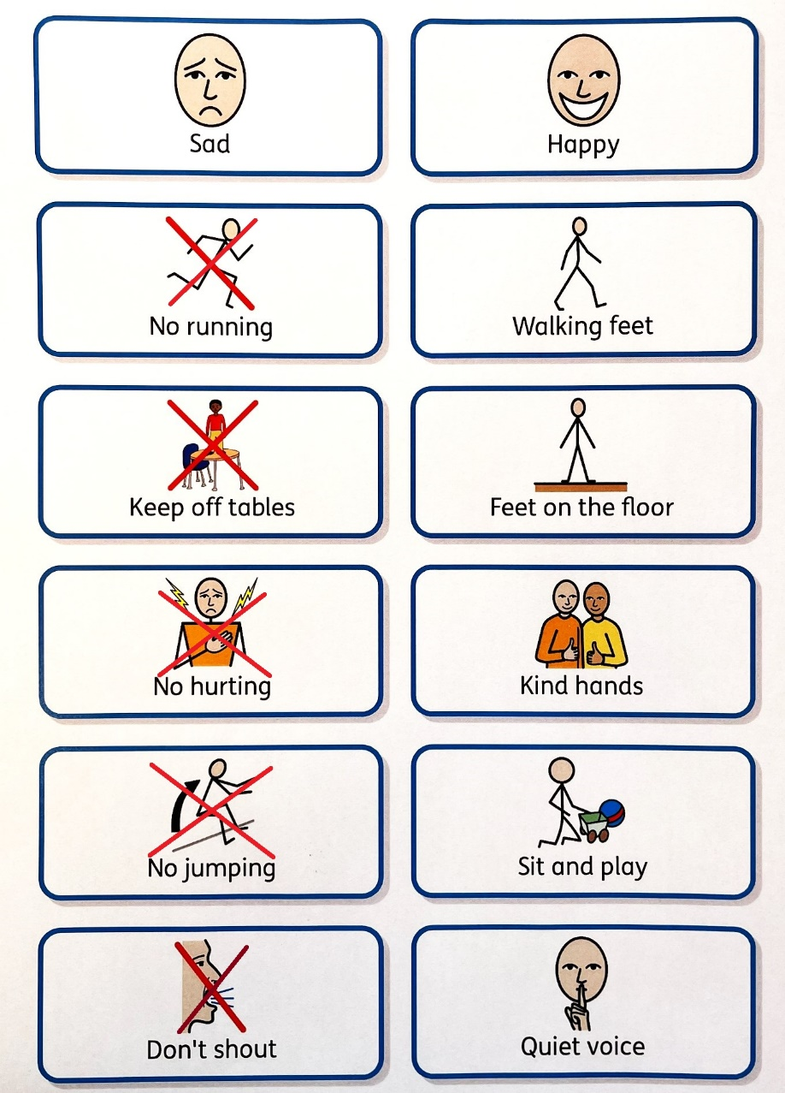
When is the Nursery open?
Monday to Friday 8am to 4.30pm
Please be on time when dropping off and collecting your child as children get upset if they see others arriving or leaving at different times.
You must let us know in advance if someone different is collecting your child. Please ring on 01536-514240 if this is a last minute decision.

Attendance

Nursery places are in great demand so please use your place well. To enable your child to get the most from what the nursery offers it is important to come regularly.
However, if your child is unwell please do keep them at home until they are better.
All our policies relating to admissions, attendance and medical conditions can be found on the school website.

If your child has sickness or diarrhoea please keep them at home for 48 hours after the last bout, as this spreads very quickly with young children.

If your child is absent from nursery for any reason, please let us know on 01536-514240
Thank you.

If you wish to take your child on holiday during term time you must let the nursery know. Please note this may affect your entitlement to funding from the local authority and may result in a charge

Term Dates 2025-2026
Autumn Term 2025 | Staff Training Days and Home Visits: 1st, 2nd and 3rd September 2025  Re-open from: Thursday 4th September 2025  Training Day: Friday 24th October 25  Half Term: 27th October to 31st October 2025  Re-open: Monday 3rd November 2025  Training Day: Friday 19th December 2025  Christmas Holidays: 22nd December to 2nd January 2026
Spring Term 2026 | Training Day: Monday 5th January 2026  Re-open: Tuesday 6th January 2026  Half Term: 16th to 20th February 2026  Re-opens: Monday 23rd February 2026  Easter Holidays: Monday 30th March to Friday 10th April 2026
Summer Term 2026 | Re-opens: Monday 13th April 2026  May Bank Holiday: Monday 4th May 2026  Half Term: Monday 25th to Friday 29th May 2026  Last Day of Term: Friday 17th July 2026  Training Day: Monday 20th July 2026

Consumables
We ask for a voluntary donation of £3.00 per week (or £15 per half term) to cover the cost of the food your child receives as snack and some consumable resources. Where children attend for 30 hours, we ask for a voluntary donation of £5 each week (or £25 per half term). Any surplus money is put towards treats for the children. Please put the money in an envelope with your child’s name and the amount clearly marked on the outside and hand in to the office. We are happy to receive money weekly, monthly or termly. Thank you

